**United States Department of Agriculture**

Food and Nutrition Service

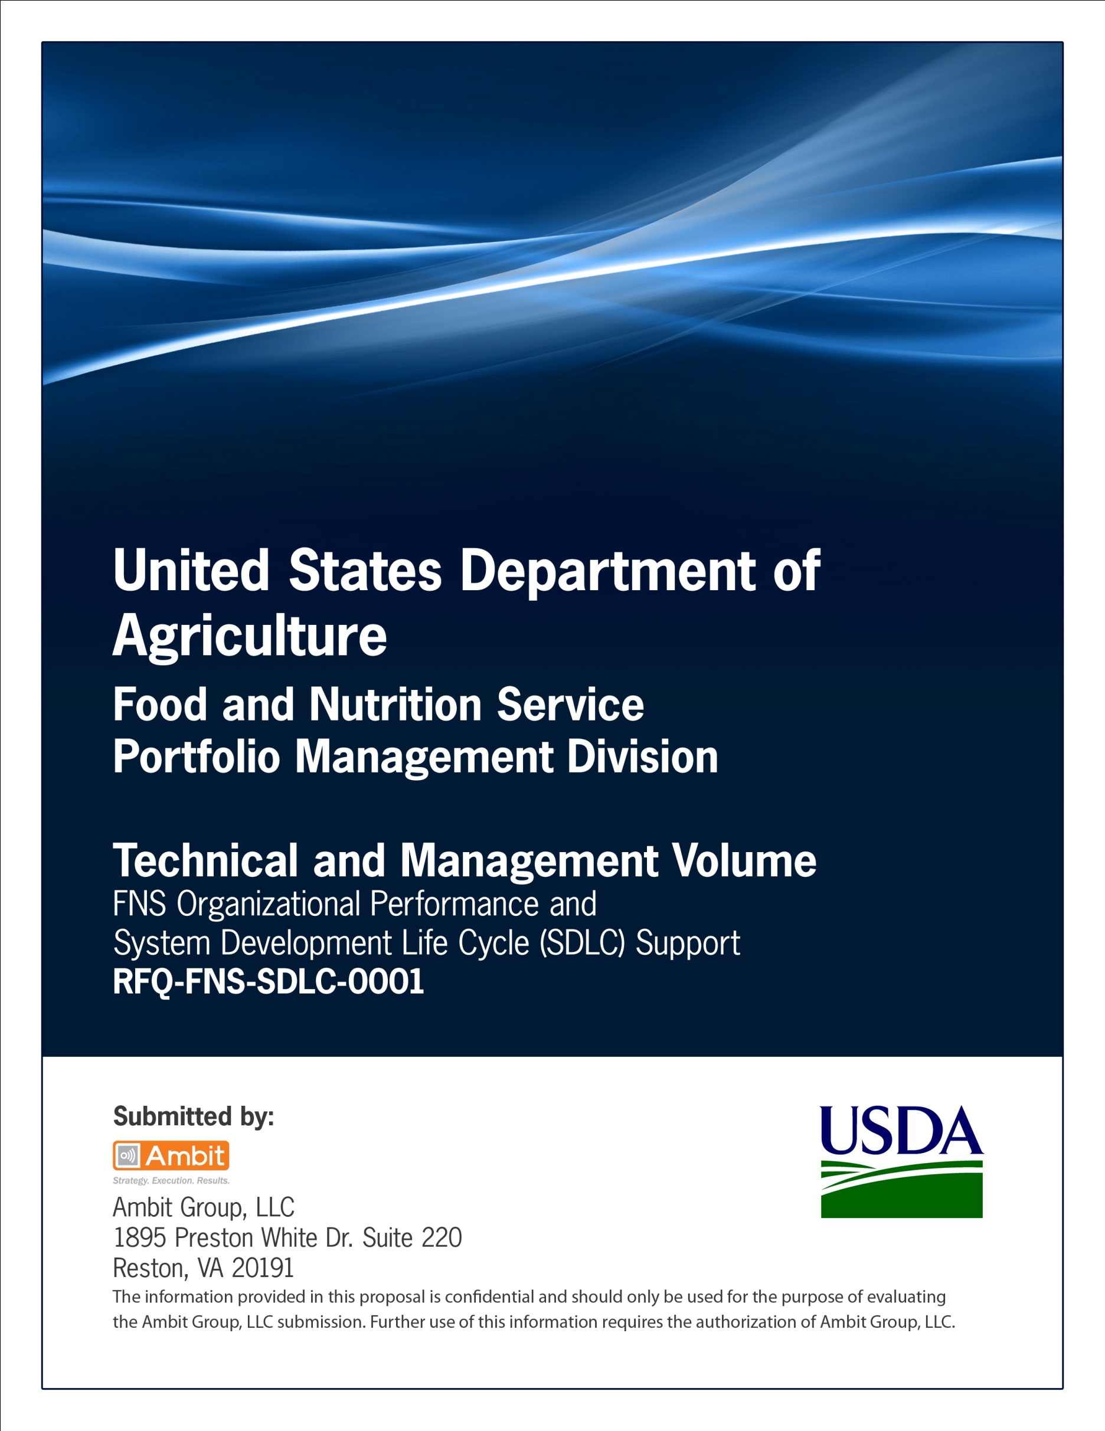

**Office of Information Technology**

**Portfolio Management Division (PMD)**

**FNS Acquisition Strategy Template**

**For**

**[System or Project Name]**

**Version 1.1**

September 09, 2013

**Revision History**

|  |  |  |  |
| --- | --- | --- | --- |
| **Version** | **Date** | **Author** | **Change Description** |
| 1.0 | 03-12-2013 | IT Governance Branch (ITGB) | Created the document. |
| 1.1 | 09-09-2013 | IT Governance Branch (ITGB) | Re-formatted the document. |
| 1.2 |  |  |  |
| 1.3 |  |  |  |

**Contact Information**

|  |  |
| --- | --- |
| **Area of Concern** | **Contact Person** |
| IT Governance Lead | Kevin Russ |
| SDLC Coordinator | Syed Jaffery |
| ITIRB Coordinator | Sunny Dilawari |
| Portfolio Management Division Director, Chief Portfolio Officer | Jacqueline Butler |
| Program Management Branch Chief | Allison Willcox |

Contents

FISCAL YEAR 2013 ACQUISITION STRATEGY 4

Approvals/Signatures 5

# FISCAL YEAR 2013 ACQUISITION STRATEGY

1. Program Office Name: ____________________________

2. Contracting Officer's Representative or other Contact and Phone Number:

______________________________________________

3. Project Title: ________________________

4. Type: { } New Contract, open market

{ } Modification to Existing Contract Number ___________________________

{ } Task Order # 2 to Contract or BPA Number __________________________

{ } GSA FSS or other government wide contract

1. Is this a proposed contract for advisory and assistance services? { } Yes { }No
2. Is this a proposed contract for a commercial item or service? { } Yes { } No
3. Is the proposed contract for services and suitable for utilizing performance-based contracting techniques? { } Yes { } No *(See Exhibit D)*
4. Funding: Total Price/Cost for NEW contracts only, including all options $ _______________.

FY 2009 estimated funding only $________________

9. Recommended Method of Procurement:

{ } Full & Open Competition { } Competitive Small Business Set-aside

(also includes GSA/FSS) (also includes GSA/FSS)

{ } Other than Full & Open { } 8(a) Set-aside *-* Sole Source <$3,000,000

Competition (Sole Source) { } 8(a) Competitive >$3,000,000

{ } Other___________________________________________________

*For GSA FSS Schedule awards, you must still indicate competitive small business set-aside or ‘Other’ for large businesses. Keep in mind the Agency’s policy is to give preference to small businesses before considering large business concerns.*

10. Could this be set-aside to a small service disabled veteran-owned business? { } Yes { } No

*(See Exhibit E)*

1. Projected date completed Request for Contract will be sent to CMB via IAS: ___________
2. Desired Date of Award: ____________ Period of Performance:_____________________ *(Specify the total number of months, including all option periods, if exercised)*

Synopsis: On a separate sheet of paper, provide a brief description of the project that will appear in the Forecast. *(Applicable to competitive actions only, including GSA/FSS )*

# Approvals/Signatures

The undersigned acknowledge that they have reviewed the [name of document] document and agree with the information presented within this document. Changes to this document will be coordinated with, and approved by, the undersigned, or their designated representatives.

|  |  |  |  |
| --- | --- | --- | --- |
| Signature: |  | Date: |  |
| Print Name: |  |  |  |
| Title: |  |  |  |
| Role: | [Project or System Name] Project Manager |  |  |
|  |  |  |  |
| Signature: |  | Date: |  |
| Print Name: |  |  |  |
| Title: |  |  |  |
| Role: | [Project or System Name] Business Owner |  |  |
|  |  |  |  |
| Signature: |  | Date: |  |
| Print Name: |  |  |  |
| Title: |  |  |  |
| Role: | Organization’s Approving Authority |  |  |